Enable Docker Remote API
- If you are running Docker host on a remote server and you want to connect to it from your laptop, you can use REMOTE API and connect to it using REST API's and docker engine accepts REST Requests.
- Let’s say you have application and want to get the details of the container in the docker host, we can use REMOTE API

## Enable Docker REMOTE API ##
The entire docker configurations are resent in "/etc/init/docker.conf"
-- Open the docker.conf file, search for DOCKER_OPTS and add values as shown below.

** DOCKER_OPTS='-H tcp://0.0.0.0:4243 -H unix:///var/run/docker.sock'
The above command will bind the docker engine server to the Unix socket as well on TCP port 4243. “0.0.0.0” means, docker engine accepts connections from all IP addresses.
** Service Docker restart
Now remote API is enabled on Docker host.
### Test using Curl ###
Get the IP Address of Docker host where we enabled remote API and execute the following command from any terminal which supports curl
** curl -X GET http://127.0.0.1:4243/images/json
The above command will output all the images in your docker host in JSON format.
## Test using REST Client ###
Test the API using REST client like Postman, if we use following URL in our REST Client, we will get the JSON output as shown below
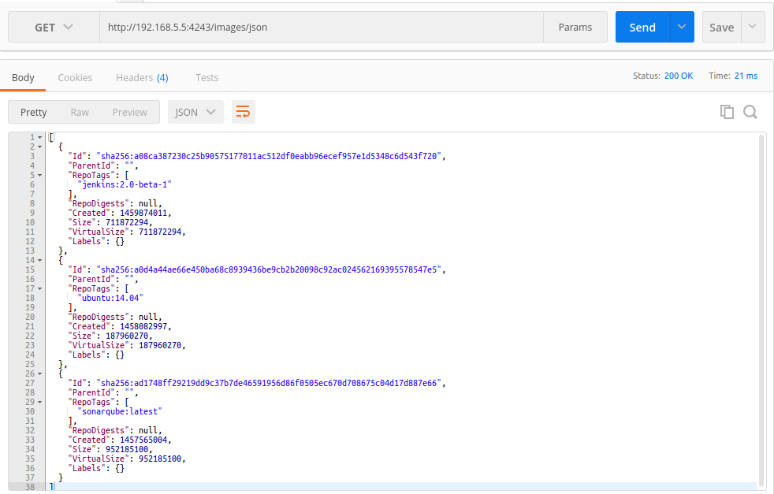

These are steps followed to enable Docker remote API, for better security we can use certificates with the REST requests.

